**University of Juba**

**School of Computer Science and Information Technology**

**Department of Computer Science**

**Online Hotel Booking System**

**By**

**Simon Baglio lako**

**Index Number: 16-CCS-101**

**A Research Project submitted to the School of Computer Science and Information Technology, University of Juba in partial fulfilment of the requirements for the award of Bachelor of Science (Honors) in Computer Science**

**Supervised by**

**Mr. Emmanuel Lomoro**

**February, 2024**

**CHAPTER ONE**

1. **Introduction**

According to Afriyie (2012), hotel reservation means booking hotel services in advance or before reaching to the destination. Through this, a client is able to access hotelier services such as rooms to pass the night, food among others depending on his/her own wish in time to avoid getting frustrated when what is needed is over or fully occupied. Now Bidgoli (2011) defined online hotel reservation system as the software application /tool to store, publish and update the dynamic data about the availability and prices of the hotel accommodation, and provides users with a regular reservation. Previously Customers were mostly being constrained with the usual practice where they had to look for a hotel more so when arrived in the particular place, walk in physically and find out whether there is a service one may wish to book. In case that there is nothing, a customer still continues to move to next closest hotel to enquire once more and this could make customers really stranded Chen (2013) Therefore, the study carried out aimed at developing an online hotel reservation system to enable customers book for whatever they need from wherever location they are before lodging into the hotel. The system is to allow for easy access and retrieval of information and reporting. With such a system in place, Juba Grand Hotel would be more competitive in Juba City of South Sudan.

* 1. **Background of the study**

Juba Grand Hotel is a hotel well known for providing its customers with clean and comfortable place to stay for a short period of time say one, two days or a week, place for refreshment, entertainment and protection of the visitor. It’s a private hotel running in Juba City, Central Equatoria in South Sudan and is located along the River Nile near South Sudan stadium. The hotel is employing more staff to cope up with the increasing amount of paper work and hotel payments by the clients in booking all over the country. The hotel currently uses the manual system to hold all external and internal correspondence relating to clients and staff. A lot of documents concerning different payments and information are labeled and stored in cabinets at the hotel. For security purposes, South Sudan is a growing tourist destination, there has been a good rise in the number of hotels and resorts in South Sudan and the tourist sector is broadening thus the need for making Hotel Reservation System website. The rapid development and commercialization of Information and Communication Technologies (ICTs) for the travel and tourism industry has prompted hotels and other enterprises in this sector to increasingly adopt these technologies. The ICT based products and processes help the hotels to enhance the operating efficiency, improve the service experience as well as provide a means to access markets on a global basis.

**1.2. Problem Statement**

In South Sudan there are more than 500 hotels which are gaining their international customers, but online booking system site is implemented by some renowned hotels only so the hotel reservation system is one of the projects that will be required in the South Sudanese tourist sector. Google Maps are also not in use and we are implementing it which will help the customer to find out the location of hotel. Customer Relationship Management is also established and we are maintaining it which will help to find out customer repository.

In Juba grand hotel, it is difficult for the customer to book hotel online before reaching their final destination in South Sudan which sometime prompted customer to look for some alternative hotel especially when they found that all the rooms are booked. Therefore, this system will help the Juba Grand Hotel and its customer offers a simulated environment to let users perform what they could do in the real world via its simple and user-friendly interface.

* 1. **Main Objective**

The Main Objective of this project was to develop a computerized hotel booking system that shall help in tracking clients’ requests efficiently and also to assess the level of Online Reservation system usage in South Sudan Hotels and how the system can be rolled out to all the hotels and improve the level of customer service delivery.

* 1. **Specific Objectives**

The specific objectives of the study were;

1. Save the client’s information into the database prior to Booking or Check in.
2. ii. Customize the type of Hotel rooms with prices.
3. iii. Booking for the customer for specific date with advance payment.
4. iv. Check in into the hotel for the duration.
5. v. Checkout from the hotel after payment operation.
   1. **Scope**

This project is only limited to Juba Grand Hotel and it does not includes other hotel within Juba City of South Sudan.

* 1. **Significance of the Project**

The Internet technology has been reached a significant achievement and we almost could get any information we need via surfing on the Web browser at 7 anytime or anywhere where computer and Internet are available. The Online Hotel Booking System offers a simulated environment to let users perform what they could do in the real world via its simple and user-friendly interface. Online Hotel Booking System meets most functions and efficiency of a real Web-based application of the real-life case and offers the extension of future development for more completed capabilities.

On completion of the study, a computerized hotel booking tool that tracks clients’ requests as they move through offices as their transactions are processed was developed. The tool generates reports on the status of clients’ requests which are accessible to the staff hence reducing on the time clients spend waiting for responses when they inquire about the progress made with their requests. To the staff, the tool helps in tracking the transactions being done through generation of summary reports.

* 1. **Limitations of the system**

1. The “finance and account” aspect of the HMIS will not capture the budget function; it only captures the accounts receivables and accounts payable.
2. Another limitation of the system is that customer’s signature will not be captured. This process might make procedures cumbersome, which is what the study hopes to eliminate; however it captures full details of the customer.
3. The system is not designed to run off-line.
4. Due to time constraints certain fields were not included; the software was therefore reduced to covering critical aspect of hotel management.

**CHAPTER TWO**

**LITERATURE REVIEW**

**2.0. Introduction**

This chapter highlights a survey of the literature about the different systems used and the problem at hand, with the intention of placing the current study in the block of research carried out.

**2.1. Definition of the key terms**

This section defines terms and abbreviations used in the Hotel Booking System project document.

**Apache -** Apache is an open source HTTP server for UNIX, Windows NT, and other platforms. '

**Browser -** A program which allows a person to read hypertext. The browser gives some means of viewing the contents of nodes (or "pages") and of navigating from one node to another.

**ER Diagram -** Diagrams that use Entity-Relationship model to design or describe database.

**Graphical User Interface.** A graphics (icons and pictures text. User enters data using user interface based or and menus) instead of both a mouse and keyboard.

**HTML -** Hyper Text Markup Language. HTML is the lingua franca for publishing hypertext on the World Wide Web- It is a non-proprietary format based upon SGML, and can be created and processed by a wide range of tools, from simple plain text editors.

**HTTP -** Hyper Text Transfer Protocol. The client/Server protocol that defines how messages are formatted and transmitted on the World Wide Web.

**HTTPS-** Hyper Text Transfer Protocol by SSL (Secure ‘: Sockets Layer). The secure version of HTTP provides authentication and encrypted communication. .

**Hyperlink -** A link from a hypertext files to another location or file; typically activated by clicking on a highlighted word or icon at a particular location. On the’ ‘screen. ... ; \ :: .

**MySQL -** Structured Query Language. MySQL is an open source relational database management system (RDBMS) that uses Structured Query Language (SQL), the most / popular language for adding, accessing, and processing data in a database.

**PHP -** Hypertext Preprocessor. A widely used general-purpose scripting language that is especially suited for Web development and can be embedded into HTML.

**Information Systems:** Information systems refers to all computer based applications that healthcare providers use to help them deliver services to their clients.

**2.3. Perception of other researchers towards a computerized system**

Relative advantages and complexity have been identified as the information systems characteristics that influence a potential adopter towards information systems adoption. Thong (1999) said that relative advantage is the benefit gained from adopting the innovation. According to a study on the adoption of PACS (Picture Archiving and Communication Systems) conducted in the healthcare industry in Taiwan, both adopters and non-adopters agreed that the healthcare industry is competitive. Hung et al(2010) argued that the adopters of information systems tends to utilize them as a tool for increasing customer satisfaction and improving medical service quality in order to help the hospital gain relative advantage and ultimately increase operation performance.

According to Rogers's (1983) innovation theory, an individual forms an attitude toward the innovation, leading to a decision to adopt or reject and, if the decision is to adopt, to implementation of the innovation. The perception of the potential adopter toward the IS is the primary determinant of IS adoption. Based on a meta-analysis of the technological innovation literature concerning characteristics of innovations, Tornatzky and Klein (1990) identified relative advantage, compatibility, and complexity as innovation characteristics that are salient to the attitude formation. Relative advantage is the degree to which an innovation is perceived as better than its precursor. The positive perceptions of the benefits of IS should provide an incentive for the small business to adopt the innovation. Compatibility is the degree to which an innovation is perceived as consistent with the existing values, needs, and past experiences of the potential adopter (Rogers, 1983). If the IS are compatible with existing work practices, the small business will be more likely to adopt them. Complexity refers to the degree to which an innovation is perceived as difficult to use (Rogers 1983). The perceived complexity of the IS is expected to influence the decision to adopt them negatively. Mohamad and Jamaludin (2009) argued that ERP software attempts to integrate business processes across departments onto a single enterprise -wide IS. The major benefits of ERP are improved coordination across functional departments and increased efficiencies of doing business. Other immediate benefits include reducing operating costs, such as lower inventory control cost, lower production costs, lower marketing costs and lower help desk support costs. Mugeni et al (2012) in their research on evaluating factors affecting broadband adoption in Kenya argued that relative advantage of broadband internet over it’s predecessor narrowband internet was very influential in explaining variations in broadband intention. Considering the items used to measure this construct, notably faster download speeds, higher reliability, better quality of service and better quality of experience, policy makers and regulators are called upon to foster an appropriate enabling environment. For example service and platform competition would spur improvement in download speeds, reliability, quality of service and quality of experience. Availability of a national broadband strategy would also serve as blueprint for broadband development and clearly set targets of download and upload speeds, among others.

**2.4. The role of information systems in an organization**

The information system is vital for any organization be it for survival or to keep up with the competition or to even get ahead of it in the current age. We can find a small family-owned restaurant to a fitness gym all making use of the information system in some way for their business (Wallace, 2015). Bigger cooperation makes use of such technologies to bring innovation and get ahead of the competition. Decision making, operational management, customer interaction, collaboration on teams, strategic initiatives, and individual productivity are the six major roles of information systems in an organization (Wallace, 2015). The following discussion post looks into two of those roles relating to Often Serious Technologies.

Information System (IS) helps in the decision-making process by providing business intelligence which can be used to analyze and understand the current trend, user habits and a lot more. This also helps counter the decision-making pattern of managers and executives based on their gut feeling alone. IS helps make informed decision and strategies for better success rate (Powell & Dent-Micallef, 1997). Relating this scenario to my current working environment, the organization I’m with heavily uses IS for decision making purpose. The use of data generated by the information system in place is used as a medium to get the knowledge and warn general people along with the government about the risk level of water in rivers. The system analyzes the level of water to do so. Also, rather than playing a guessing game on the amount of rainfall, the organization has placed stations around Nepal and in other country offices on the amount of rainfall on a particular day in collaboration with its partners. That helps analyze the information and make concentrated strategies for agriculture (crop harvest cycle). Aside from that, there is a magnitude of usage within the organization for decision making including for formulating web and social media strategies by analyzing user pattern, identifying the need of a new project/initiative, GIS analysis and much more.

Information System has opened a whole new world by enabling people and organization to collaborate with teams from any part of the world. With tools like Skype, Office365, TeamViewer and even the power of self-developed systems, teams can now communicate and collaborate on projects while discussing, sharing files, remotely access the desktop to name few actions from anywhere. Again relating this point to the organization I’m at. The organization has its head office in Nepal but presence in some way in other country offices. Many staffs are often on travel thus the collaboration aspect becomes significant. Skype is often used to have a meeting and discussion with remote staff or when someone is on travel and need to discuss something. Along with that, SharePoint platform is used to build the intranet which houses most of the organization information that is to be shared internally. Office365 is used for collaboration while editing documents. This is of significance as anything going out of the organization need to go through an editing process to ensure quality. Going back and forth on the document via email or in-person is tedious and time-consuming so rather a system is built such that the editor and the writer can seat together virtually to ensure that the quality is met. So, the information system enables collaboration between teams to ensure that the organization can conduct meetings, share document, interact virtually and even work remotely to ensure that the crucial organization function can be performed from anywhere and anytime.

**2.5. Related Systems for Hotel Management System**

Hotelogix Hotel Management software is a user friendly, uncluttered and compact Hotel Management System that automates the operation and management of a hotel, our software seamlessly integrates Online & Offline Reservations, Front Desk. Developed by Hotelogix Inc and released on Aug 01, 2007.

HotelASP is a hotel software, hotel reservation software and hotel management system for managing hotels, motels, villas, or other kind of properties. HotelASP provides reservation management, room stay and lodging management, planning, and customer management. Account management, front office and back office reporting. HoteIASP is also a Hotel Application Service Provider. Developed by WinSaaS and released on May 12, 2008.

ASIFD is a general purpose hotel & motel software which is can be used as a hotel maintenance software, hotel reservations software, hotel management software, hotel billing software, general purpose hospitality software, hotel accounting software, hotel accommodation software, hotel property management software (pms)and as hotel booking software and as software for online hotel reservation. Developed by Anand Systems Inc and released on Feb 05, 2006.

Free Hotel Software is a general purpose hotel & motel software which is can be used as a hotel maintenance software, hotel reservations software. hotel management software, hotel billing software, general purpose hospitality software, hotel accounting software, hotel accommodation software, hotel property management software (PMS, PM Software) and as hotel booking software and as software for online hotel reservation. Developed by Free Hotel Software a released on Oct 28, 2006.

SIMSOFT Hotelpro 2006 hotel software offers a low-price hotel management system which has complete solution for daily hotel operations, includes front office as well as back office ftinctions (reservation, billing, payment, reports, inventory, housekeeping, bookkeeping). Hotelpro will assist in managing complex operation quickly, saving time & costs. Networking environment is also supported to synchronize front desk operations with all functions. Developed by SIMSOFT Indonesia, eZee FrontDesk is a general purpose hotel and motel software which is can be used as a hotel maintenance software. Hotel reservations software, hotel management software. Hotel billing software.

Hotel property management software (prns). Developed by eZee Technologies It is ideal solution for hotel having 10-100 Rooms. Main Features include.

Hotel status from main screen with easy Check in Check Out, Reservation, Group Management/ Operations, Direct Billing! City Ledger.

iMagic Hotel Reservation - reservation software is an affordable, simple to use and install hotel booking software system for guesthouses, small hotels, hostels, and bed and breakfasts. iMagic Reservation was developed for the needs of small to medium accommodation management. The program has reservation, room management, billing, accounting, and statistics capabilities.

ASI Front Desk Hotel Software is a general purpose hotel & motel software which is can be used as a hotel maintenance software, hotel reservations software, hotel management software, hotel billing software, general purpose hospitality software, hotel accounting software, hotel accommodation software, hotel property management software (pms)and as hotel booking software and as software for online hotel reservation.

ApPHP Hotel Site is a powerful hotel management and on-line reservation site script. This script is the fully functional PHP solution to manage small to medium size of hotels, holiday flats or guesthouse. Visitors of Hotel site will be able to search rooms’ availability with an online booking reservation system. They also could view rooms’ inventory, check availability, and book reservations in a real time.

Joomla HBS - Joomla Hotel Booking System was designed to simplify the task of online booking in Joomla Content Management Website. Joomla HBS is Easy to install, simple to manage and reliable. Joomla HBS (Joomla Hotel Booking System) is the leading Online Hotel Booking solution for Joomla.

KingSmart Hotel Systems Suite 2005 offers Hotel Property Management Systems, hotel management software, reservation software, Restaurant, Spa and Conferences POS software and hotel back office Accounting, Stock and Payroll software to hotel, restaurant and leisure businesses. Download KingSmart HPMS and POS Standard 2005 or visit compw.com for more products from HotelPro 2000, 3000 to KingSmart 5.0, 2003 and 2005, KingSmart Hotel Software - Hotel Management System is able to be configured to your specific requirements making it easy to use and to obtain fast, accurate information for your individual hotel.

Sai Soft Hotel Catering Software is a dynamic hotel and motel software which improve guest service while achieving profitability. This software is ideal solution for all kind of property. Main features include: Quick check-in/out, hotel status from the main menu, Direct billing, Expense management, Transaction management with insert, delete and edit features, back up and resort of data, importing and exporting of guest data and many more. It also has the facility of POS with touch screen which in result increases your sell and profit. We also have multiple rate and seasonal rate type with single stay.

Dahlin et al., (2005)[4] developed a scalable and time responsive monitoring system called INSIGHT that tracks continuous queries and efficiently gathers local information about data streams into an aggregate view. The system is a distributed monitoring framework for constructing large-scale data aggregation and continuous event monitoring applications, such as IP traffic monitoring, network anomaly detection, accounting and bandwidth provisioning, sensor monitoring and control, and grid resource monitoring.

Kane (2006) [6] describes an Online Tracking Information System (OTIS) which is a collection of search engines which enable Environmental Protection Agency (EPA) staff, state/local/tribal governments and federal agencies to access a wide range of data relating to enforcement and compliance. This Web application sends queries to the Integrated Data for Enforcement Analysis system. The Integrated Data for Enforcement Analysis system copies many EPA and non-EPA databases monthly, and organizes the information to facilitate cross-database analysis. Online Tracking Information System can be used for many functions, including planning, analysis, data quality review, and pre-inspection review.

Tunity Technology Pte Ltd (2003) [10] developed a Personnel Tracking System for Prison Security that improves the efficiency of the prison personnel management and operational processes. Tunity developed a wristband tag with an anti-tamper feature. Inmates under monitoring wear the wristband tag which transmits an alert signal if it is tampered with. The tag transmits a signal every 1.5 seconds (selected time interval), identifying the inmates and their respective zonal positions within the monitoring area.

The Internal Revenue Service of the United States Department of Treasury (2004) acquired a Tax Litigation Counsel Automated Tracking System (TLCATS) for tracking all aspects of tax litigation cases. TLCATS is an on-line interactive and batch processing system used by Chief Counsel personnel to store and retrieve case data throughout all phases of the tax litigation process. TLCATS also tracks trial calendars and provides the United States court with information on the status of the cases on each trial calendar. In addition, TLCATS provides Chief Counsel Management with case statistics at various organization levels.

Ontario Environment Ministry (2007) uses a web-driven application called the Provincial Groundwater Monitoring Information System (PGMIS) to monitor the state of the province’s ground water resources. The information from the Provincial Groundwater Monitoring Network provides an early warning system for changes in water levels as well as changes in water quality. This information supports informed decision making on water issues, drought management and land use planning.

Main (2001) and Lim and Huang (2005) highlighted the weak position of nonaffiliated hotels vis-à-vis affiliated hotels in relation to their exploitation of Electronic Distribution Centers. This weakness will be exacerbated as the complexity of Electronic Distribution Centers continues to increase if hoteliers do not develop effective Electronic Distribution Center management strategies. An Electronic Distribution Center management model designed to address the key issues relating to Electronic Distribution Center management would be useful, a perspective supported by Hudson (2008). Furthermore, the different issues related to Electronic Distribution Center management in hotels are to be discussed and investigated.

The design of travel and tourism websites has received substantial attention by scholars (e.g. Schegg et al., 2002; Law and Leung, 2002; Law and Wong, 2003; Scharl, Wober and Bauer, 2003; Landvogt, 2004; so and Morrison, 2004; Essawy, 2005; Jeong et al., 2005; Law and Hsu, 2006; Zafiropoulos and Vrana, 2006; Schmidt, Cantallops, and dos Santos, 2007). Landvogt (2004) evaluates several online booking engines over 23 different criteria, like overall user friendliness, payment method, instant confirmation, reliability, and invoicing function among others. These criteria present some of system’s functions and design principles discussed further in current paper.

In their study Jeong et al. (2005) find that only two characteristics of hotel websites (information completeness and ease of use) are important determinants of perceived website quality. These results are bewildering as most studies identif~’ more dimensions of perceived service quality to be significant for website users. Law and Hsu (2006), for example, assess the dimensions of hotel websites (information regarding the reservation, hotel facilities, contact details of the property, surrounding area and website management) and attributes in each dimension mostly valued by online users. Some of the most important website attributes are found to be the room rates, availability and security of payments (in the reservation information dimension), the location maps, hotel and room amenities (in facilities information), telephone, address and e-mail of the hotel (for contact information), transportation to the hotel, airports and sights (for surrounding area information), and up-to-date information, multilingual site and short download time (for website management). So and Morrison (2004) apply similar criteria for website evaluation as the preceding study but they group them into technical, marketing, consumer perspective and destination information perspective criteria.

Essawy (2005) focuses on website usability and shows that severe usability problems with interface quality, information quality, and service quality affect negatively the purchase and revisit intentions of website users. The author identifies some of the practical tools/activities for increasing users’ perceived satisfaction, purchase intention, and potential relationship building — exchanging links with local points of interest, shorter/simpler pathways to leisure breaks, greater depth of information for room facilities and pricing, providing proactive interactions, and avoiding third-party reservation systems. In similar vein, Scharl, Wober and Bauer (2003) assess the effectiveness of hotel websites.

Authors identify personal, system and media factors that contribute to hotel website adoption. In the system factors group, that is more controllable by the hotel management compared to personal and media factors, they identify the perceived utility of the product, speed of the system, intelligence, layout, services, languages, navigation, interactivity, reliability of the system.

Research has also shown that trust is an important dimension of website development (Fam, Foscht and Collins, 2004; Chen, 2006; Wu and Chang, 2006). If consumers do not trust the website they will not visit it, or will not transform their visits into real purchases.

Although much effort has been put towards evaluating the design of tourism websites and the identification of website attributes highly valued by customers, there is a gap in the research in the OHRS design and its specific problems have not received enough attention in previous research with few notable exceptions. In series of reports Bainbridge (2002, 2003a, 2003b) discusses the practical aspects of the OHRS design (the search option in the systems, the booking process and the date format), while Ivanov (2002, 2005) discusses the types and main characteristics of OHRSs and the major marketing decisions to be taken by the marketing managers in their design.

**CHAPTER THREE**

**METHODOLOGY**

**3.1**. **Introduction**

In this chapter, we discussed the software development methodology in this project. This methodology is used in software development, where different phases are used during the implementation stage which involves breaking a project into rational stages. Each phase can be treated as an individual project with its own objectives, and requirements. By breaking projects down, individuals or companies software developers can control the scale and pace of their launch.

**3.2 Software Development Methodology**

The waterfall development methodology was selected for this project. There are four main phases in this methodology which include planning phase, analysis and design phase, development, testing phase, as well as closing phase. Each phase started only when the previous phase is finished. However, the development and testing phase done iteratively until the system is fully developed. In general, the highest priority features were created before the other features. As they require respectively longer time for implementation. The next phase started once the previous phase finished.

The overview of the phased development methodology is shown in Figure 3.1.

Planning

Analysis and design

Closing

Version 1

Version 2

Version 3

Server and database implementation

Testing

Application Implementation

Testing

Application integration

Testing

Phase one

Phase two

Phase three

Figure 3.1 Software Development Methodology.

**3.3 Description and Analysis of Existing System**

This is a problem solving method that decomposes a system into its module pieces for the purpose of studying how well those component parts work and interact to accomplish the intended objectives. System analysis is a term that together describes the early phases of the system development. As of recent, Juba Grand Hotel still go through the manual process of booking rooms in Juba and end up getting a paper booking receipt which:

1. Is not secure.
2. Takes long times to get.
3. Involves spending a lot of cash to obtain.
4. Is not efficient

The effectiveness, consistency and reliability of any system depends largely in terms of the result or output produced by the system. The output produced by this manual process of requesting for hotel booking is very worrying about. In other to improve on the output, this project aims to develop a Web application for hotel booking request that would allow customer to be able to book for their rooms at any time they need, at any place and get it in a digital format which is cheaper and secure.

**3.4 Analysis of the Proposed System.**

The proposed system is made up of a two level architecture, the front-end, which is the actual program and the back-end which is the underlying database. The user interface would consist of two section for the users section. The user would be able to book on the website. Then the user can login to the website with a user-name and password. The user fills an booking form then afterwards then submit it to the system. The user the pays the necessary fee for the selected room booked after reaching the hotel in cash. Then the administrator section, the admin logins to the website. The admin is able to see all the booking applicants at once, the admin is able to view the details of each user that have booked, The admin makes necessary verification and he can then allocate the room after verifying customer payment.

The database will store the information:

* About the details of booking users who have applied
* Details of the admin

**3.5 Functional Requirements.**

Functional requirements shows what the system does and is expected to do. It is a description of activities and services a system need to provide. These requirements are tangible and more easily identified.

* Booking

Users book on the web application by supplying basic information to ensure they are legitimate

**Viewing**

This functionality allows the admin to be able to view the details of an applicant

**Approving**

This functionality enables the admin to approve room for the customer.

**3.6. Non-Functional Requirements.**

These are not associated with any functions of the system but these requirements allow for a better and higher quality system to be produced.

* Stability

The system should work faultlessly and error messages are to be virtually eliminated. If the system was online, it would be expected to be running regardless of the load of users simultaneously accessing the system.

* Fast response time

To achieve satisfaction on all users, the response time of the proposed system should be preserved carefully. Most of the users will feel irritated or disturbed to wait for an extended loading time. Hence, user might not want to continue by the time loading ends. Performance of the system is also important as users will determine the success of a proposed system.

* User interface

Basically, it is important that the proposed system achieve features that are user-friendly so that it will be applicable for all users. Functions in the system should be understandable so that users can adapt to use the system easily and quickly.

**3.7. Use Case Diagram.**

Use case diagrams have two important components, the actors and use cases. The actors represent people who will have a key role in the system and the use cases represent the main functions in the system. Linking an actor to a use case illustrates that a specific actor initiates specific function.

Customer

Admin

Figure 3.1: Use case diagram for online hotel management system

It shows the two actors in the system which are the admin and the customer. It shows the functions they perform represented by oval.

**3.8. Data Flow Diagram.**

The Data Flow Diagram (DFD) is a graphical representation of the flow of data through the information system. It allows the user to represent the processes in the information system from the viewpoint of data. The DFD lets you visualize how the system operates, what the system accomplishes and how it will be implemented, when it is refined with further specification. Data flow diagrams are used by systems analysts to design information-processing systems but also as a way to model whole company.

Booking

Admin

Web application Room booking request

Login

Update users

View customer

Approve room

Search customer

Booking for Room

Login

Register

Figure 3.2 Data Flow Diagram for the Proposed System

This gives an overview of the proposed system, it shows the flow between the admin and the system and the flow of data between the citizen and system

**3.9. Entity Relationship Diagram.**

E-R model is one of the commonest and successful types of data model around. Its basic elements are: Entities, Attributes, and Relationships.

Customer

Rooms

Billing

Admin

Book

Pay

Manage

Figure 3.3 E-R Diagram of Proposed Online Hotel Management System

**3.10. Chapter Summary**

This chapter focuses on the analysis of the existing system and the proposed system. It discusses about the functional and non-functional requirements of the system. The functions in the system is represented with a Use Case diagram. The flow of data in the system is represented with a Data Flow Diagram. The database schema of the system is represented with an Entity-Relationship diagram and Entity-Relational Diagram.

**CHAPTER FOUR**

**SYSTEM IMPLEMENTATION AND DOCUMENTATION.**

## **4.1. Introduction**

This chapter provides a complete description of the system and its users. Then it demonstrations the choice of programming language, system requirement, software requirement, implementation model,

**4.1 The Programming Language Used.**

The software was developed using PHP, MSQLI, and Bootstrap template. PHP was used in developing the package because it allows RDBMS facilities such as file table manipulation and relational capabilities. It allows indexing and searching of database. It minimizes the need for memory allocation, variables etc.

**4.2 System Requirements.**

The hardware and software specification selected for this system were sensibly selected, taken to deliberate the expected large volume of data to be handled by the hotel, types of processing needed to achieve meaningful objectives, cost of obtaining the hardware and software components.

**4.2.1 Hardware Requirements.**

The system will function effectively on smart phone, tablets, desktop and laptop computer with the following specifications:

* 32MB for RAM
* A monitor screen
* Intel(R) with at least 1.33GHz Processor speed
* At least 250MB Had disk
* Keyboard

**4.2.2 Software Requirements**

The software requirements include:

* Web browser
* Windows 8, 8.1, 10
* Web Server

**4.3 Implementation.**

The patterns of operations and characteristics of the framework established in previous sections in conjunction with the deductions made by the software systems developer, determined to a large extent the technique of implementation. Analysis tools such as Use case Diagrams, Data flow diagram, Entity Relationship models were converted to their corresponding data structure. PHP framework incorporated all these stages into a single system that could manage and control all activities and processes in the project.

The Online Hotel Management system indicates that it has two major interfaces the admin and the citizen interface these interfaces are dependent on the logic in the main application for their functionality. The main application pulls data that is to be displayed on these interfaces from a database through a database management system over a network.

**4.4 Screen Shots for website.**

Below are the screen shots of the website interface design

The customer browse the juba grand hotel website at jubagrandhotel.com to register and book a room. The chosen username and password will be used to login anytime.

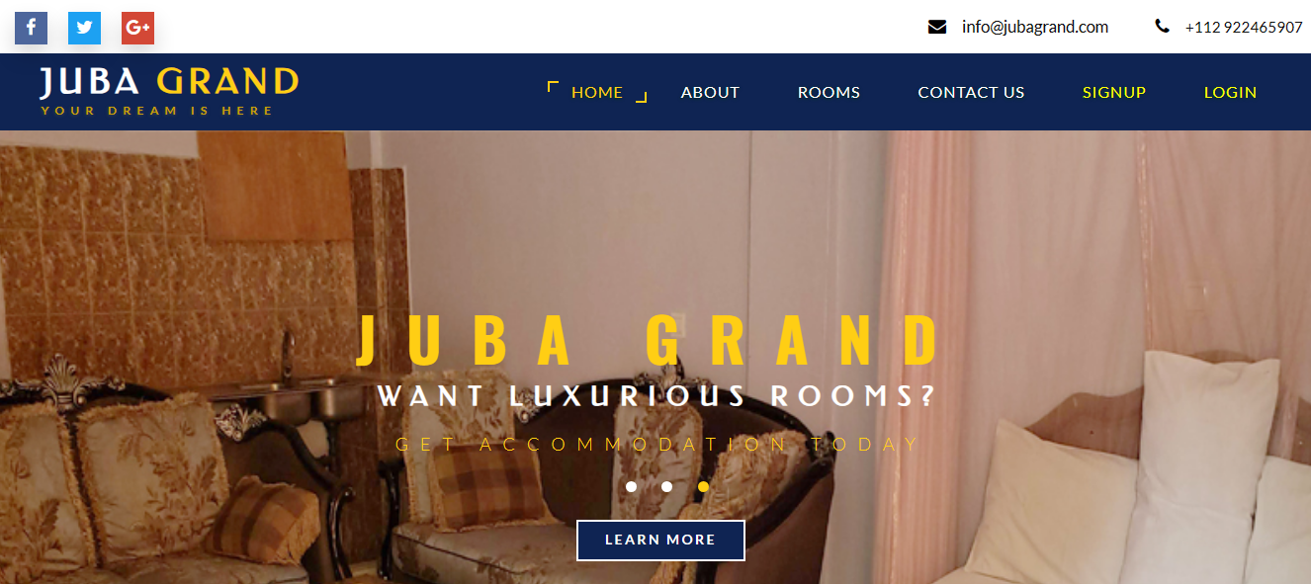

**Figure 4.2 Signup page**

The signup page allows a customer to sign up into the system, it allows unregistered customer to navigate to the signup page so as to register.

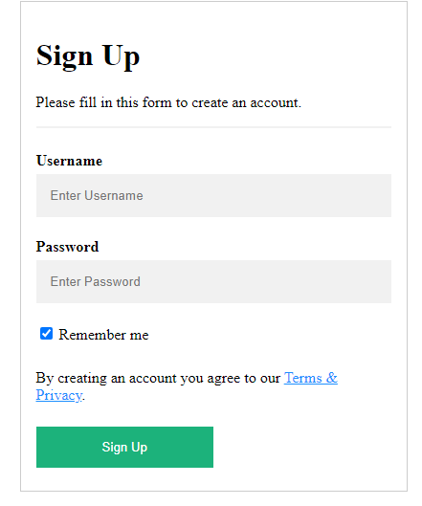

**Figure 4.5 Customer Login Page**

This page allows a user to fill in his/her username and password to login to book a room in Juba Grand Hotel

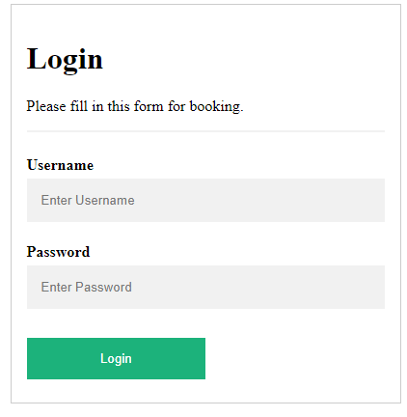

**Figure 4.6 Admin Dashboard**

This is the page where the admin manage full customer details and grand customer access to enter the room after paying the required bill.

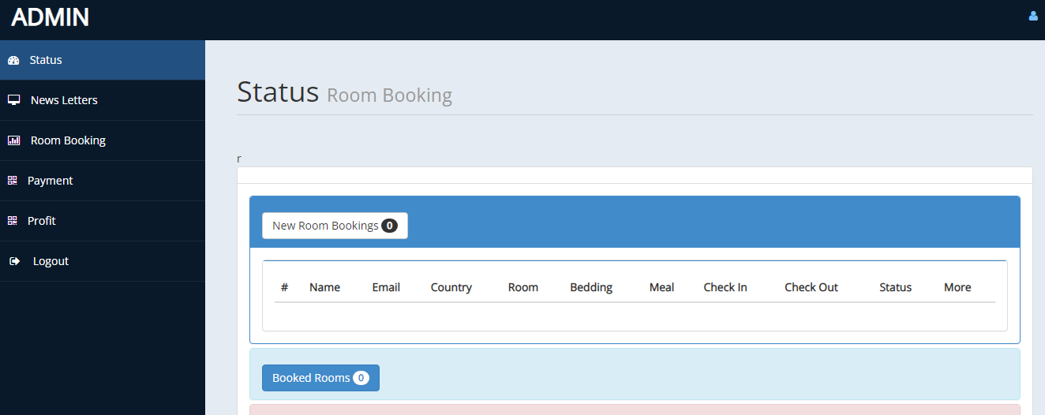

**Figure 4.7 Customer booking Page**

This is where customer fill the form in order to book for the room.

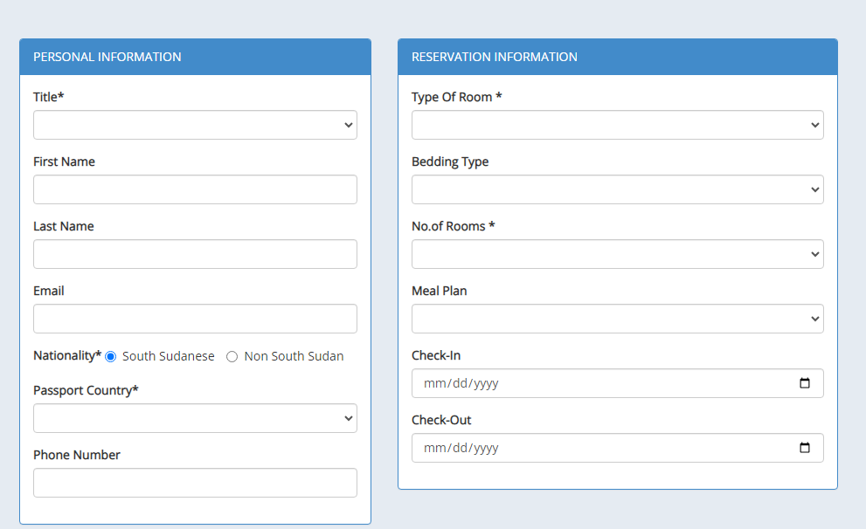

**4.5. Chapter Summary**

This chapter talks about the choice of programming language used, the system requirements, the hardware requirements, the software requirements, the functions used in the program, and the screenshots of the software.

**CHAPTERFIVE**

**SUMMARY, CONCLUSIONN AND RECOMMENDATION**

**5.1 Summary**

This project is titled “Online Hotel Management System” using the Juba Grand Hotel as a case study. This project was carried out because of the need for customer to book for hotel rooms which helps the Juba Grand Hotel to have record thereby leading to the development of a Hotel Management System that will enable the customer to book online.

The system has different modules which are sign up, login, fill booking form, and pay for the rooms and update profile and approve rooms by admin.

**5.2 Conclusion**

In conclusion, the system should be able to perform all the modules and purpose of its development which is to enable customer to book faster, and efficiently.

**5.3 Recommendation**

During the design of this system every effort was made to integrate the appropriate functionalities into the system with all software application where one cannot foresee every functionality required by the users. It is therefore my recommendation that effort be taken to review customers report on the system in order to know which part of the system required improvement on and which functionalities to be added.

**5.4 Chapter Summary**

This chapter provides a summary of the whole project and conclusions drawn at the end of the project as well as the recommendations.

**References**

1. Chopra Rashi,(2006),International Journal of Advanced Research in computer and communication engineering
2. Corbett,Eludire,(2009),The Design and Implementation of hotel Management System Research Journal of Applied Sciences, Engineering and Technology pg3707-712
3. Devin,(1981),database structures and design 2 nd Edition
4. El-Altar,M.S.T,(2010),Design and implementation of information systems,London wiliams.K
5. Gommans et al,(2014),international journal of scientific and research publication,IV
6. Isakowitz et al,(1998),web information system
7. Ismail Quarchli,(2015),Research Journal of Applied Sciences, Engineering and Technology Research Journal of Applied Sciences, Engineering and Technology page 3707-712
8. Krammer,et al,(2007),The role of information and communications technology sector in expanding economic opportunity corporate social responsibility initiative report
9. Kroenke, David,(2015),Mis Essentials Boston Pearson
10. Kryder L.G,(2003),Introduction to information systems london John.P
11. Laudon,(2007),Fundamentals to business information systems
12. Merriam-Webster,(1999),System analysis and designBoston
13. O’Brien,Marakas,(2011),Introduction to information systems
14. Rajapakse,(2012),A fresh graduate guide to software development Tool and technologies
15. Scholes,Mingers,(1990),Introduction to Structured Analysis and Design
16. Stonier,Thomas,(1997),Introduction to information systems London
17. Taylor,S.S,(2007),Comments on hotel booking by Mechanical Engineering Teaching Assistants Journal of Business and Technical Communication 402-424
18. Powell, T., & Dent-Micallef, A. (1997). Information technology as competitive advantage: the role of human, business, and technology resources. Strategic Management Journal, 18(5), 375-380.
19. Wallace, P. (2015). Introduction to information systems (2nd ed., pp. 2-4). Upper Saddle River, N.J.: Pearson.
20. Mounika Nandiraju (2020).International Research Journal of Modernization in Engineering Technology and Science